IMPLEMENTATION OF CONSTRAINT SATISFACTION PROBLEMS

**AIM:** To Implement constraint satisfaction problem

**CODE:**

class Graph:

def init (self, edges, N): self.adj = [[] for _ in range(N)] for (src, dest) in edges:

self.adj[src].append(dest) self.adj[dest].append(src)

def colorGraph(graph): result = {}

for u in range(N):

assigned = set([result.get(i) for i in graph.adj[u] if i in result]) color = 1

for c in assigned: if color != c:

break

color = color + 1 result[u] = color

for v in range(N):

print("Color assigned to vertex", v, "is", colors[result[v]]) if __name == ' main ':

colors = ["","BLUE", "GREEN", "RED", "YELLOW", "ORANGE"]

edges = [(0,1), (0,3), (0,4), (1,0), (1,4), (1,2), (2,1), (2,3), (3,0), (3,4), (3,5), (4,0), (4,1), (4,2),

(4,3), (4,5), (4,6), (5,3), (5,6), (5,4), (6,4), (6,5)]

N = 7

graph = Graph(edges, N) colorGraph(graph)

**OUTPUT:**

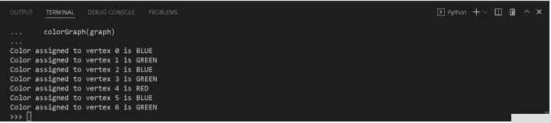

**RESULT:** Constraint satisfaction problem is successfully implemented